**Class Design**

1. **CREATE INITIAL DESIGN CLASSES**
2. **DEFINE RELATIONSHIPS BETWEEN CLASSES**

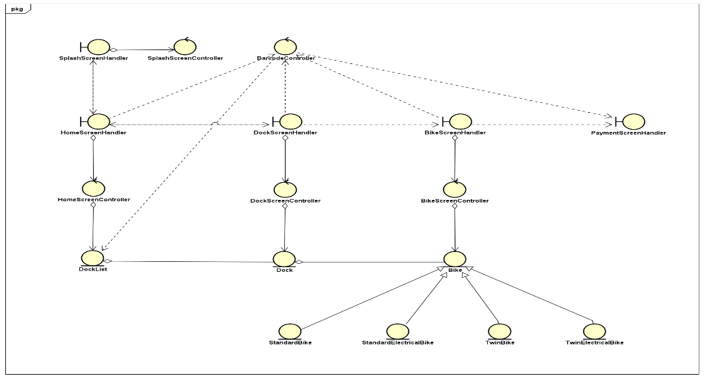

1. **CLASS DESIGN**

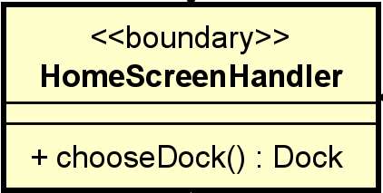**3.1. Class “HomeSceenHandler”**

**Attribute**: None

**Operation**:

|  |  |  |  |
| --- | --- | --- | --- |
| **#** | **Name** | **Return type** | **Description** |
| 1 | chooseDock | Dock | handle dock tab that chosen by user |

**Parameter**:

None

**Exception**:

None

**Method**:

None

**State**:

None

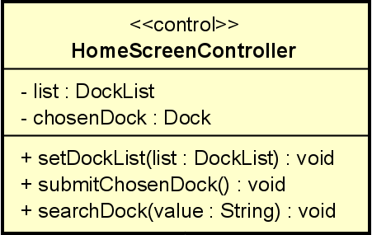**3.2. Class “HomeScreenController”**

**Attribute**:

|  |  |  |  |  |
| --- | --- | --- | --- | --- |
| **#** | **Name** | **Data Type** | **Default Value** | **Description** |
| 1 | list | DockList | empty ArrayList | List of docks |
| 2 | chosenDock | Dock | NULL | Particular dock that chosen by user |

**Operation**

|  |  |  |  |
| --- | --- | --- | --- |
| **#** | **Name** | **Return type** | **Description** |
| 1 | setDockList | void | Set the list of docks |
| 2 | submitChosenDock | void | Submit the dock chosen by user |
| 3 | searchDock | void | Search dock by name or address |

**Parameter**:

list: list of docks

value: the string that user want to search

**Exception**:

None

**Method**:

None

**State**:

None

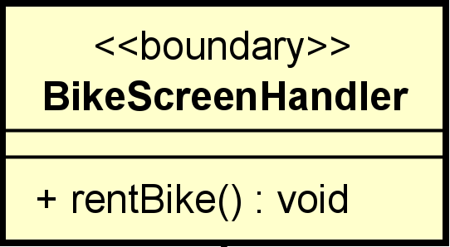**3.3. Class “BikeScreenHandler”**

**Attribute:** None

**Operation:**

|  |  |  |  |
| --- | --- | --- | --- |
| **#** | **Name** | **Return type** | **Description** |
| 1 | rentBike | void | Rent bike |

**Parameter:**

None

**Exception:**

None

**Method:**

None

**State:**

None

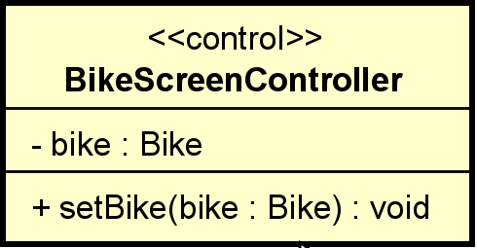**3.4. Class “BikeScreenController”**

**Attribute**:

|  |  |  |  |  |
| --- | --- | --- | --- | --- |
| **#** | **Name** | **Data Type** | **Default Value** | **Description** |
| 1 | bike | Bike | NULL | Bike chosen by user |

**Operation:**

|  |  |  |  |
| --- | --- | --- | --- |
| **#** | **Name** | **Return type** | **Description** |
| 1 | setBike | void | Set the chosen bike |

**Parameter**:

bike: Particular Bike

**Exception:**

None

**Method**:

None

**State**:

None

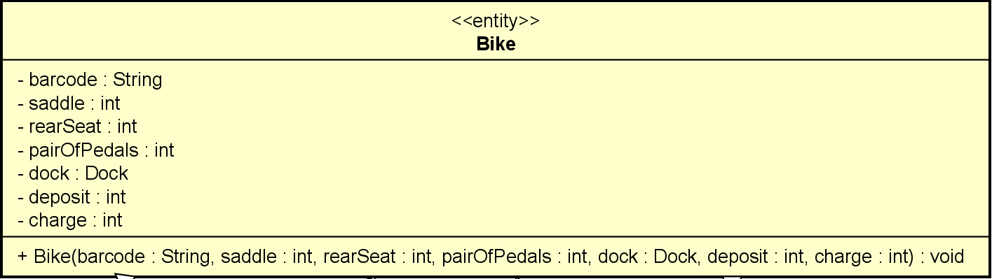 **3.5. Class “BikeScreenController”**

**Attribute**:

|  |  |  |  |  |
| --- | --- | --- | --- | --- |
| **#** | **Name** | **Data Type** | **Default Value** | **Description** |
| 1 | barcode | String | NULL | Barcode of the bike |
| 2 | saddle | int | 1 | Number of saddle |
| 3 | rearSeat | int | 1 | Number of rear seat |
| 4 | pairOfPedals | int | 1 | Number of pair of pedals |
| 5 | dock | Dock | NULL | Dock where bike is locating |
| 6 | deposit | int | NULL | Deposit money of bike |
| 7 | charge | int | NULL | Charge of renting |

**Operation:**

|  |  |  |  |
| --- | --- | --- | --- |
| **#** | **Name** | **Return type** | **Description** |
| 1 | bike | void | Initialize the info of the bike |

**Parameter**:

bike: Barcode of the bike

saddle: Number of saddle

rearSeat: Number of rear seat

pairOfPedals: Number of pair of pedals

dock: Dock where bike is locating

deposit: Deposit money of bike

charge: Charge of renting

**Exception:**

None

**Method**:

None

**State**:

None

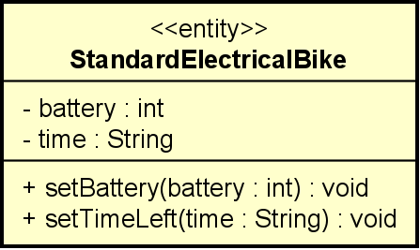**3.6. Class “BikeScreenController”**

**Attribute**:

|  |  |  |  |  |
| --- | --- | --- | --- | --- |
| **#** | **Name** | **Data Type** | **Default Value** | **Description** |
| 1 | battery | int | 100% | The percentage of the battery |
| 2 | time | String | NULL | Time left before running out of battery |

**Operation:**

|  |  |  |  |
| --- | --- | --- | --- |
| **#** | **Name** | **Return type** | **Description** |
| 1 | setBattery | void | Set the percentage of the battery of E-Bike |
| 2 | setTimeLeft | void | Set the time left before running out of battery of E-Bike |

**Parameter**:

battery: The percentage of the battery

time: Time left before running out of battery

**Exception:**

None

**Method**:

None

**State**:

None

**4. Class Diagram**

